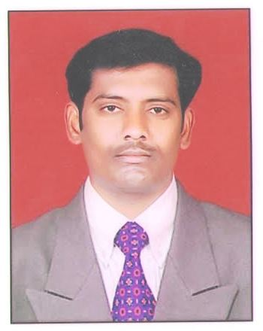
CURRICULUM VITAE

Naveenkumar Chilivery

Mobile: +919959106900
E-mail: knr1729@gmail.com

OBJECTIVE:

Seeking a job as a Math teacher utilizing ability, maintaining good communication with teachers, parents and administrators to ensure student development.

EDUCATION:

▪ Bachelor of Science- Osmania University,Hyderabad in 2002.
▪ Bachelor of Education(B.Ed.,)- Kakatiya University,Warnagal in 2006.
▪ M.Sc., in Mathematics – Nagarjuna University,Guntur in 2011.
▪ Computer Skills: Microsoft Office

PROFESSIONAL EXPERIENCE:
Sai Genius High School, Koratla June 2017 - Present
Wisdom Space High School, Metpalli. IIT-Maths Teacher June 2014 – 2017.
▪ Taught IIT mathematics to 8th,9th,10th grade students.
▪ Designed and implemented comprehensive lesson plans for the three grades: Relations and Functions, Trigonometry, Algebra, Calculus, Coordinate Geometry, Vectors and 3D Geometry, Statistics and Probability.
▪ Developed unit-based projects that are centered on real-world situations to show students the importance of gaining a solid education and how mathematics correlated with everyday life.
▪ Created assignments for all the three grades on the completion of each topic.
▪ Attended various IIT workshops for improving teaching strategies and working with autistic children.

Sri Suryodaya High School,Metpalli. Maths Teacher June 2009 – April 2014
▪ Taught mathematics to 8th,9th,10th grade students.
▪ Designed and implemented comprehensive lesson plans for the three grades: Relations and Functions, Trigonometry, Algebra, Calculus, Coordinate Geometry, Vectors and 3D Geometry, Statistics and Probability.
▪ Developed unit-based projects that are centered on real-world situations to show students the importance of gaining a solid education and how mathematics correlated with everyday life.
▪ Created assignments for all the three grades on the completion of each topic.
▪ Attended various workshops for improving teaching strategies and working with autistic children.

Vijaya Sai High School,Metpalli. Maths Teacher June 2008 – May2009 ▪
- Instruct high schools in small classroom setting in the Algebra I, Algebra II, and Geometry objectives.
▪ Develop lesson plans and curriculum for Algebra I, Algebra II, and Geometry

Sri Saraswati Sishu Mandhir High School,,Metpalli. Maths Teacher June 2006 – May2008 ▪
▪ Implemented lessons to boost basic math skills and prepare students for Algebra.

Pragati HighSchool,,Metpalli. Maths Teacher June 2002– June 2005 ▪
▪ Implemented lessons to boost basic math skills and prepare students for Algebra .

ADDITIONAL EXPERIENCE:

Having Computer knowledge MS-Office.
Having the experience of TTC Coaching.

Personal Information

Name | Naveen kumar Chilivery
Father’s Name | Narsaiah Chilivery
Marital Status | Married
Sex | Male
Languages Known | English,Hindi,Telugu
Date of Birth | 30-07-1981
Passport No. | H 2029202
Curriculum | CBSE
Skype ID | naveenkumarchilivery
Reporting | 2 or 3 weeks

Education Details :

Qualification | Marks | Board/ University | Date of passing
S.S.C | 458 (600) | Board of Secondary Education | 26/05/1997
Intermediate | 612 (1000) | Board of Intermediate Education | 21/06/1999
Degree(B.Sc - M.P.C) | 1222 (1800) | Osmania University | 11/06/2002
B.Ed | 421 (600) | Kakatiya University | 16/06/2006
P.G (M.Sc - Maths) | 458 (800) | Achaya Nagarjuna | 21/03/2011
TET ( Teacher Eligibility Test ) | 104 ( 150 ) | TSPSC

Place: Metpalle With Regards,

(Naveen Kumar)

